Health & Safety Kit

COMPANY HEALTH AND SAFETY POLICY – is posted on the Health and Safety bulletin board and tells workers, visitors etc. that the owner are committed to safety in the work place and the implementation and management of safety is the responsibility of all supervisors. All workers are aware of the safety rules and are trained in safe operating practices and they will comply with the Health and Safety Act of Ontario.

RESPONSIBILITIES are divided in order to have everyone in the workplace involved. This is called an internal responsibility system. This internal responsibility system involves everyone from employer to the worker. When everyone takes care of their safety responsibilities – injuries are avoided. When any one group ignores their responsibility someone can get injured.

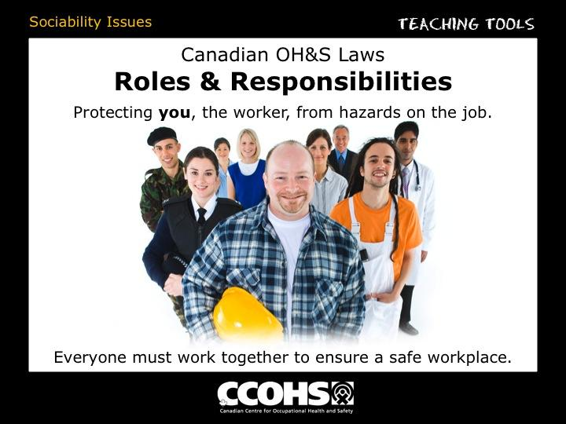
Management / Owner responsibilities Is to take all reasonable precautions to protect the health and safety of workers, contractors, and customers.

Supervisor’s responsibilities are to implement and manage the safety program.
- Ensure that a worker complies wit the act & regulations
- Ensure that any equipment, Protective device or clothing required by the employer is used or worn by the worker.
- Advise a worker of any potential or actual health and safety dangers.
- Provide training – information, instruction and supervision
- Take every precaution reasonable in the circumstances for the protection of workers.

Workers responsibility is to work safely, in accordance with the regulations set out.
- Work in compliance to safety rules
- Use and wear equipment, protective devices or clothing required by the employer.
- Report to employer, supervisor any known missing or defective equipment or PPE that may endanger a worker.
- Report any work place hazard
- Report any known contravention of the Act
- Do not remove or make ineffective any protective device required
- Do not operate any equipment or work in a way that may endanger himself or herself, or any other worker.
- Do not engage in any pranks, contest, and feat of strength, unnecessary running or rough conduct.

Joint Health and Safety committee or Representative – Identify workplace hazards, obtain information from the employer, make recommendations to employer, and investigate work refusals & serious accidents. Ask who is your Health and Safety Worker Representative?

THE RIGHTS OF WORKERS:
Workers have four basic rights;

The Right to participate: by taking part in the process of identifying and resolving workplace health and safety concerns. For example a worker has a right to sit on the health and safety committee or to attend meetings.

The Right to Know: about any potential hazards to which they may be exposed. Workers, have the right to be trained (on or before the first day of work, or before each new task) and to have information on machinery, equipment, working conditions, processes and hazardous substances such as WHMIS.

The Right to Refuse Work: if they believe is dangerous to either their own health and safety or that of another worker. By following the proper procedures set out by the Act.
Procedure: He must report to a supervisor and explain why. Supervisor must investigate the situation immediately, in the presence of the worker and, one of the following – JHSC member or another worker because of knowledge, experience and training, has been chosen by the workers to represent them.

The Right to stop work – applies with a Joint Health and Safety Committee who has a “Certified Safety Rep” if the rep felt the work was dangerous to any worker.

SAFE WORK PROCEDURES:
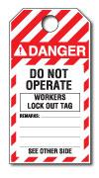
- Housekeeping Rules
- PPE - Protective equipment requirements
- Worksite and Equipment inspections are a monthly formal inspection process to help in maintaining safe conditions of your workplace and / or mobile equipment. Workers assist with completion of these inspections and complete pre-inspections of mobile equipment that they operate.
- Tag out procedure must be used when a report of a defective equipment is determined or to conduct routine maintenance on equipment. If you see a Do NOT Operate tag on a piece of equipment only the person whose name is on the back of the tag/lock may remove it and operate the equipment.

INJURY / ILLNESS / NEAR MISS / HAZARD REPORTING
Procedure – Injury/ illness/ near miss / hazard reporting
- Get First Aid immediately
- Tell your employer / supervisor about the injury

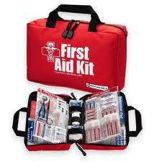
All accidents that result in a quality, customer service, equipment or personal loss must be reported to a supervisor. Remember all accidents are preventable and you don’t want them to happen again.

First Aid Reporting:
Even small accidents that result in minor first aid must be reported by logging it in the first aid kit – even if it is for a bandage.
The First Aid Attendees are:
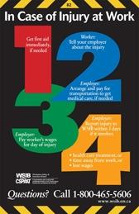

Incident Reporting
Incidents are close calls or near misses. These are warning signs that a future accident is about to happen somewhere in your workplace. Supervisors need to know about these incidents so that they can prevent a future accident. The same incident will occur over and over again unless preventative measures are developed.

SPECIFIC HAZARD INFORMATION: Supervisor will identify specific hazard on or before the first day of work.

EMERGENCY RESPONSE PROCEDURE
Workers should be aware of what to do in case of the following:
- Accidental release of toxic gases, chemical spills, fires, explosions, workplace violence.
Workers should know the plan for
- Emergency escape,
- Procedures for employees that remain to perform shut down.
- Rescue and medical personal, (who is certified in 1st Aid and CPR),
- How to report fires and other emergencies along with a contacts list.
- Who is the lead coordinator and members of the response team?
The evacuation meeting point is as located:

DISCIPLINE POLICY – Supervisors, owner, manager may have a to discipline for a worker not following safety rules or procedures. A progressive disciplinary policy includes items such as informal discussions, verbal warnings, written warnings, suspension from work or dismissal from the job. This would be up to the discretion of manager / owner.

Workplace violence means:
- The exercise of physical force by a person against a worker, in a workplace, that causes or could cause physical injury to the worker
- An attempt to exercise physical force against a worker, in a workplace, that could cause physical injury to the worker
- A statement or behavior that it is reasonable for a worker to interpret as a threat to exercise physical force against the worker, in a workplace, that could cause physical injury to the worker.
Workplace harassment means:
- Engaging in a course of vexatious comment or conduct against a worker in a workplace that is known or ought reasonably to be known to be unwelcome.
Workplace harassment may include bullying, intimidating or offensive jokes or innuendos, displaying or circulating offensive pictures or materials, or offensive or intimidating phone calls.
Ask your supervisor:
- What the company policies are with respect to workplace violence and workplace harassment.
- And what to do if Workplace violence occurs.
- How to summoning immediate assistance when workplace violence occurs or is likely to occur, and how to controlling risks described.

FIND THIS OUT:

Who is on your Health and Safety Representative or who sits on the Health and Safety Committee?

Where can the Safety Bulletin Board or information booklet be located?

First Aid Kit location:

EMERGENCY RESPONSE PLAN:

What is the plan?

______________________________________________________________

Who has first aid training in your crew?

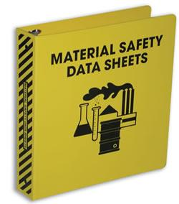
Location of the MSDS – Material Safety Data Sheets for dangerous controlled products:

Your supervisors should provide a tour of the workplace and/ or job site and reviews the job specific hazards.

OTHER HAZARDOUS AREAS TO MENTION TO NEW EMPLOYEES:

- Repeating the same movements over and over, especially if you are in a awkward position or you use a lot of force.
- Slipping, Tripping or falling
- Working near motorized vehicles
- Using or working near machinery
- Noise
- Poor lighting
- See immediate supervisor for more

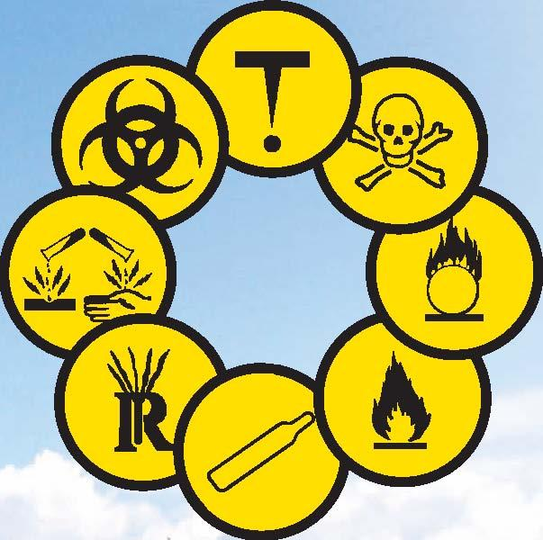
What is WHMIS – Stand for?

____________ ________________ ________________

_____________ __________

Make sure you have training in WHMIS Program, specifically the following areas;
MSDS, Work site labels & supplier labels, Understand WHMIS responsibilities and you understand WHMIS symbols.

WAYS TO PROTECT YOURSELF FROM HAZARDS:
- Best way is to get rid of or eliminate the hazard completely.
- Or if you can eliminate, your employer can try and reduce the hazard.
- Another way to reduce is to limit how long or how often you come in contact with the hazard.
- If it still exist after trying the above methods of eliminating, engineering controls and administrative or work practice controls your employer may require you to wear personal protective equipment. Such as Hard Hats, Safety Glasses and steel-toed boots

PERSONAL PROTECTIVE EQUIPMENT (PPE): Will be set out by managers, supervisors and your health and safety committee. This policy is to improve accident prevention effort and help establish valid safety goals. For Specific use of Protective Equipment see Supervisor for training. Steel toe shoes, Safety glasses, hearing protection etc..

I, _____________________________understand the above Safety rules of this company and will comply with these any other that may be set out in the future all.

Employee Signature:_________________________ Date:

Supervisors Signature: _______________________ Date
